

**Task 1: Preparing and Analysing Axial Models (Graph Analysis Tool / Attributes Explorer Tool)**

**Description**

This exercise offers the experience of a complete workflow of space syntax axial and segment analysis using the Space Syntax Toolkit for QGIS**. It involves the preparation of the axial model, correcting the axial and unlinks maps, followed by the analysis of the model using axial topological and segment angular analysis.** The results of different network measures are visualised at the end.

**Stage 1 – Project preparation**

1. **Prepare the QGIS environment**
   1. Install the **OpenLayers QGIS plugin**. This plugin adds layers based on popular on-line maps such as OpenStreetMap, Google, Bing, etc. The plugin appears in the Web menu.

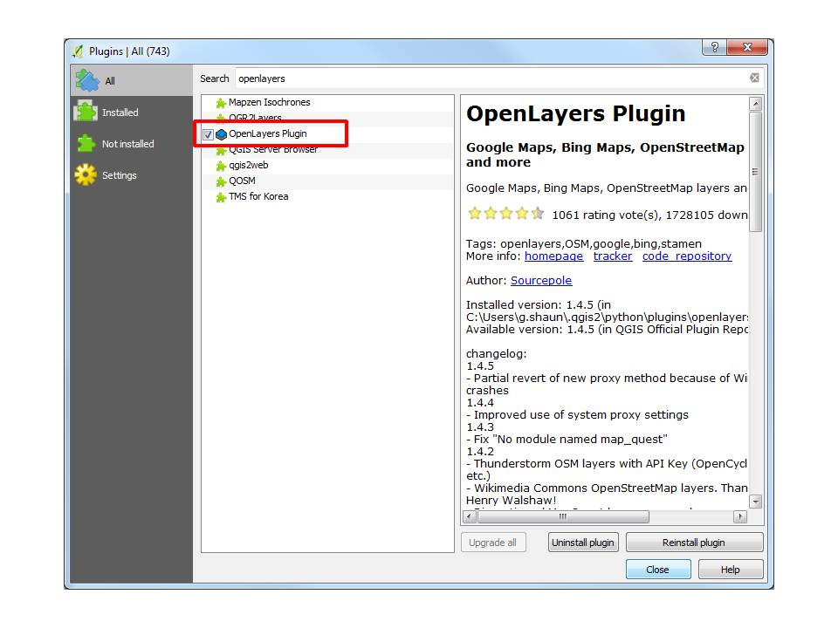

* 1. Modify your QGIS settings under **‘Settings > Options**’
     1. Select **‘Digitizing > Feature Creation’** and check **‘Suppress attribute form pop-up after feature creation’**

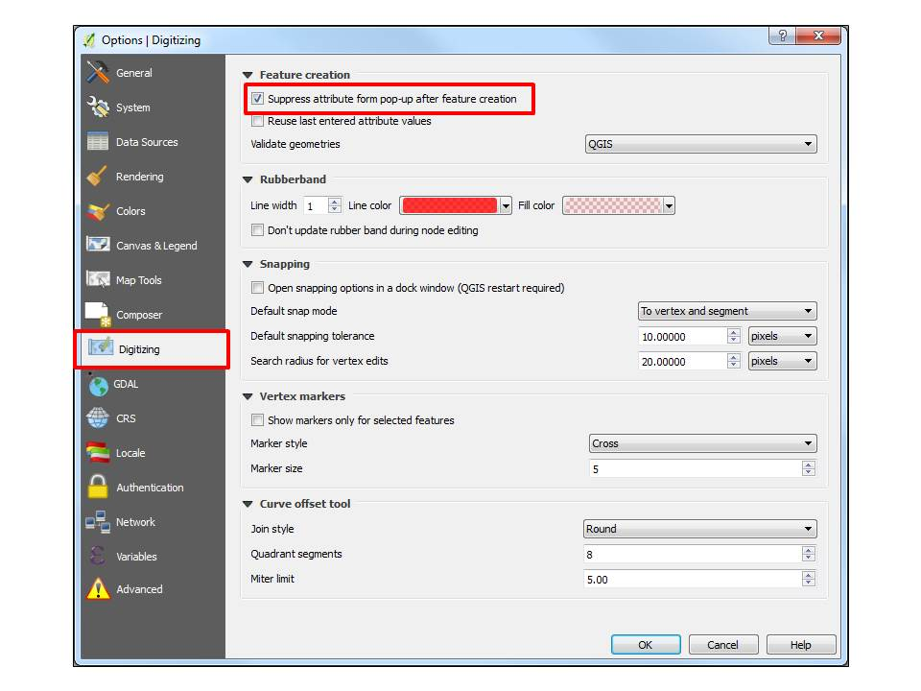

* + 1. Select **‘General> Icon size’** and type in ‘**16’** to reduce the size of toolbar icon. This will increase your screen space.

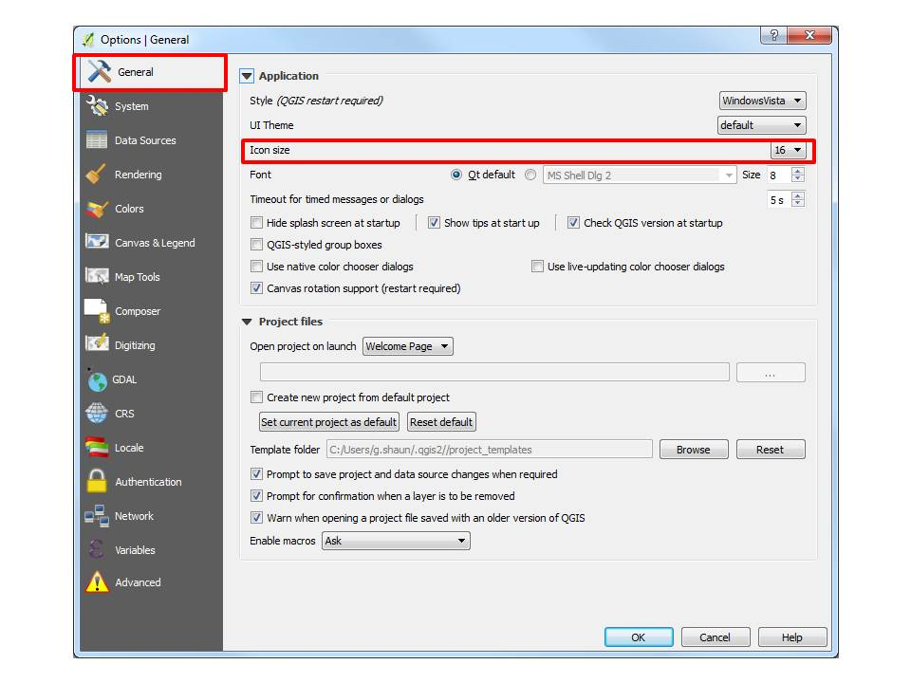

* + 1. If the GUI is not English, you can modify it in **‘Locale’** tab. Check **‘Override system locale’** and select **‘U.S. English’**. This requires a restart of QGIS.

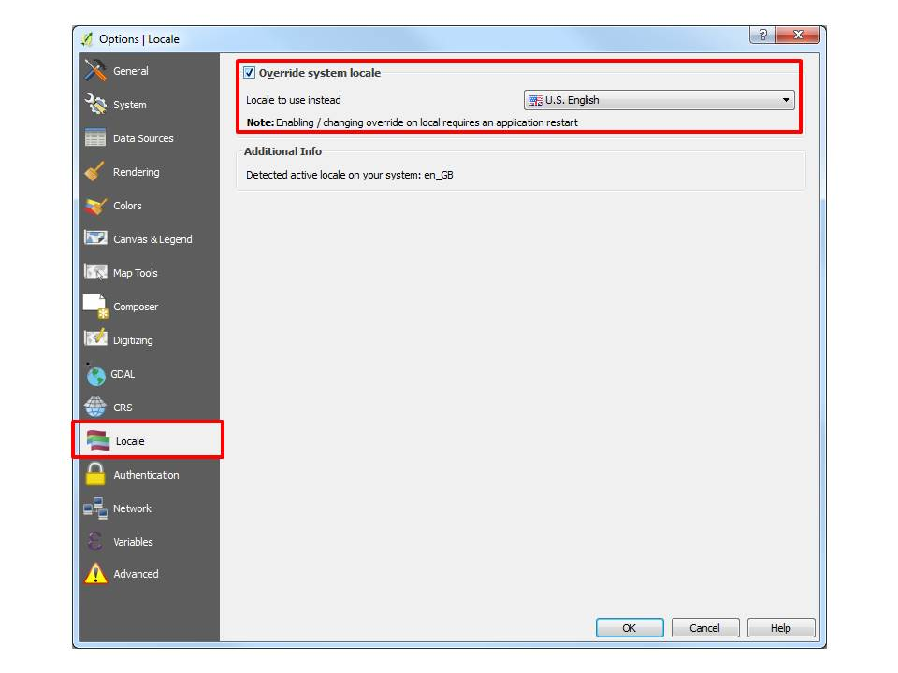

1. **Prepare the sample data**
   1. Download the sample data from the repository:

<https://moodle.ucl.ac.uk/mod/resource/view.php?id=3188819>

* 1. Unzip this into a folder in a location of your choice
  2. Open the sample data project (sample_data.qgs) by double-clicking the file OR by dragging the file onto your already-opened QGIS window OR by selecting **‘Project > Open’**
  3. Activate (Check) the Google Maps background layer in the Layers Panel

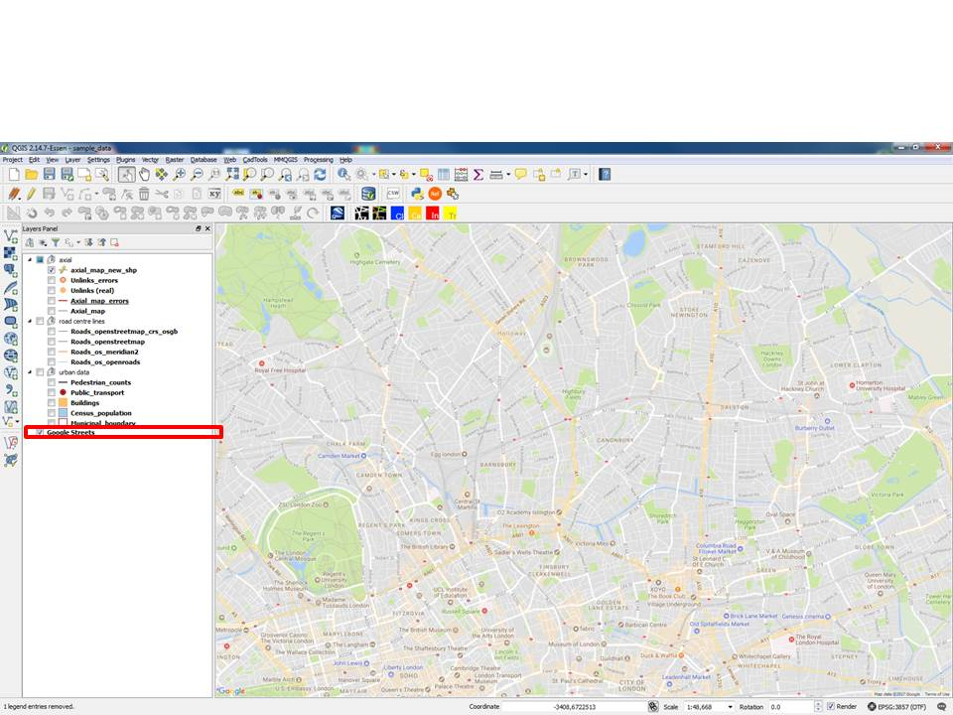

**Stage 2 – Model preparation**

1. **Create an axial map layer**
   1. Create a new shape file layer, ‘**Layer’ > ‘Create Layer’ > ‘New Shapefile Layer’**
   2. Select **'Line'** type
   3. Click the ***Globe***button to select the **CRS (Coordinate Reference System)**
   4. Type **‘27700’** in the filter box at the top and select **‘OSGB 1936/British National Grid EPSG:27700’**.
   5. Do not add any new fields, ignoring the default ‘id’ field.
   6. Click OK and save the new layer as **‘axial_map_new.shp’** (location of your choice)

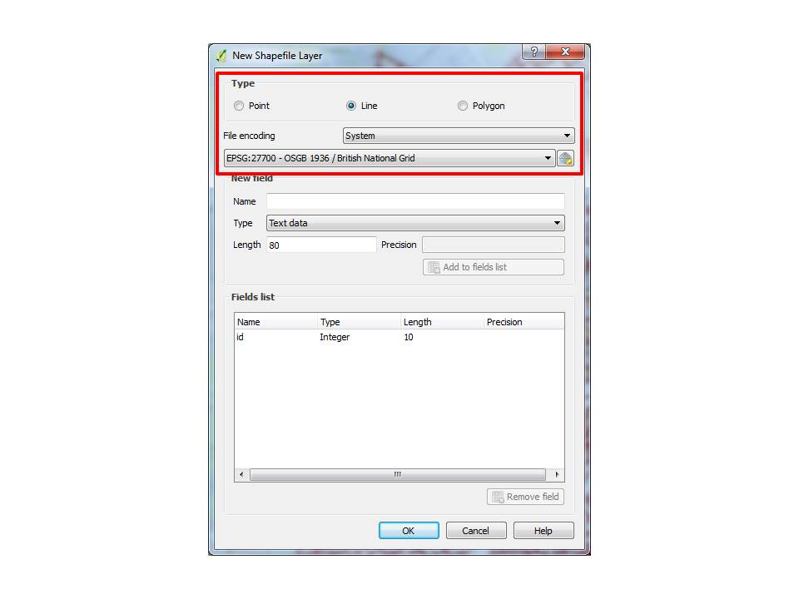

1. **Draw axial lines**
   1. Select the **‘axial_map_new’** layer in the **Layers Panel**
   2. Toggle the***Pencil* toolbar button** in the **Digitizing toolbar,** or select ‘**Layer > Toggle Editing’**
   3. Toggle the **‘Add Feature’** toolbar button
   4. Zoom into the ***Barnsbury*** area
   5. Draw some axial lines: left-click to **start**, left-click for **second point**, right-click to **finish drawing the line.**
   6. Go to **Settings > Snapping Options**
   7. Choose **‘All layers’** under ‘**Snapping mode’** and choose ‘**To vertex’** under **‘*Snap to*’.**
   8. Type in ‘**10**‘ for ‘**Tolerance’** and select **pixels** as the base unit.

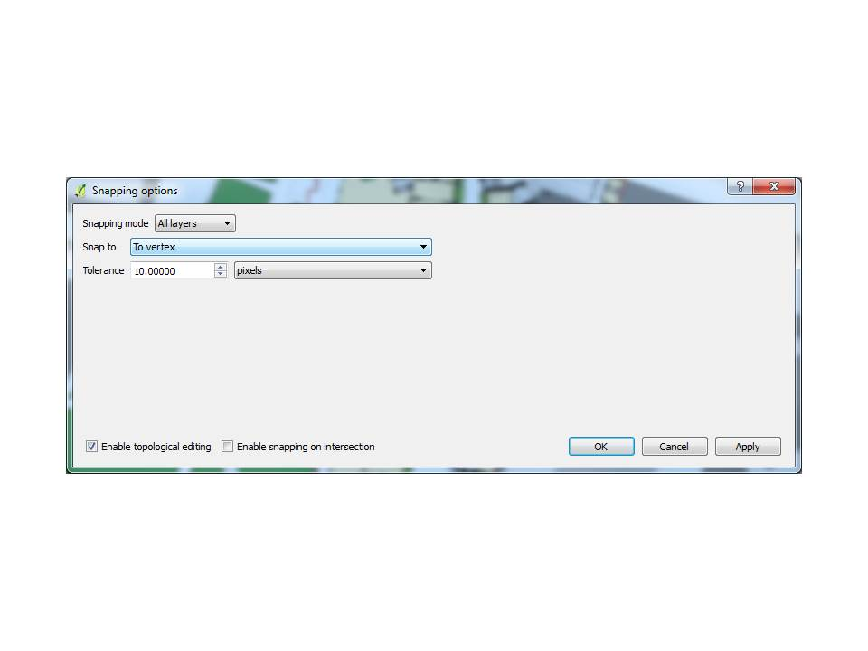

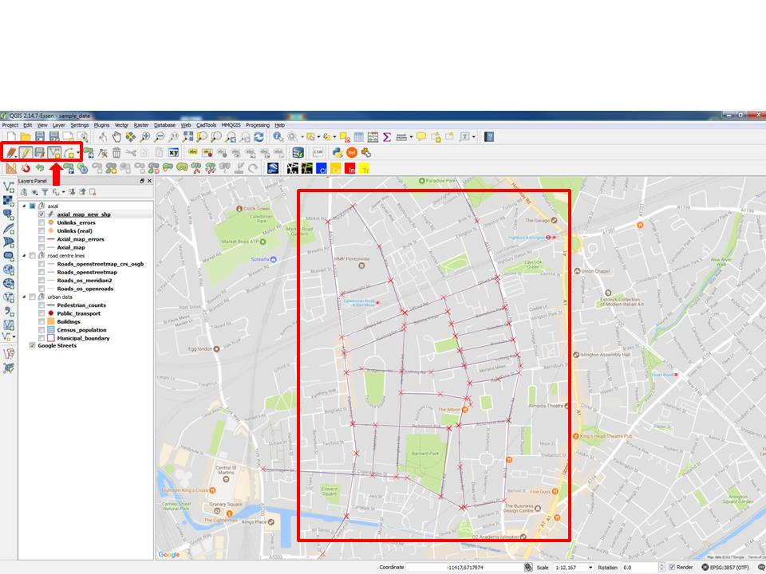

* 1. This is just for you to get some practice, you do not have to make an extensive map drawing
  2. **Do not** draw polylines, keep them as single lines.
  3. Make sure the axial lines **cross** each other distinctively.
  4. Select the **‘Node tool’** button in the **Digitizing toolbar,** and click once on the line’s vertex if you wish to modify it.
  5. Un-toggle the **‘Toggle Editing’ (yellow pencil)** button to save your file.

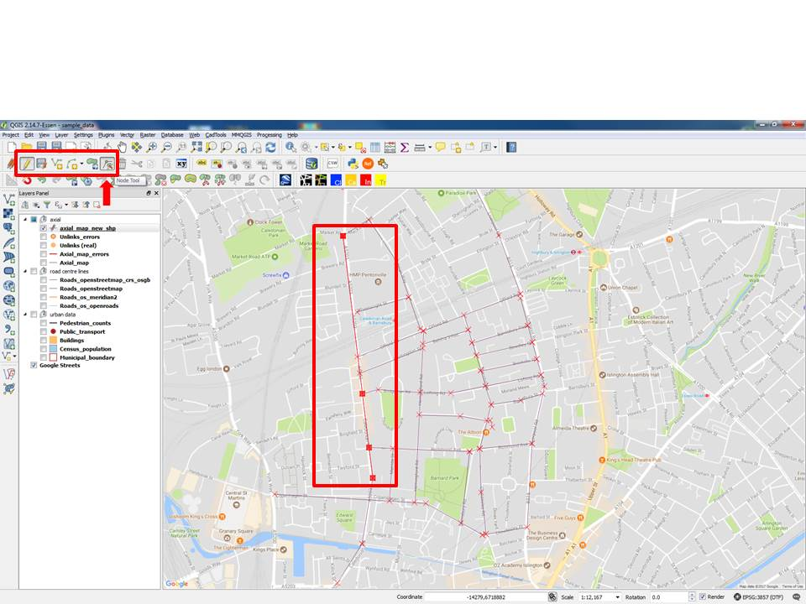

1. **Create an unlinks layer**
   1. Create a **new shape file layer**, like in Step 3.
   2. Select ***'*Point'** type
   3. Set the **CRS** **to EPSG: 27700** like before. Now it should be in the CRS drop-down menu.
   4. Click ‘OK’ and save the new layer as **'unlinks_new.shp'** (location of your choice)



1. **Draw unlinks**
   1. Select the **‘unlinks_new’ layer** and toggle the **edit button** *(yellow pencil).*
   2. Draw a few unlinks points using the ‘**Add Feature’ tool** in the Digitizing toolbar
   3. Position them near locations where lines cross.
   4. This is just an exercise: The unlinks don’t have to be real locations. Look at the layer ‘Unlinks (real)’ to see the single *real* unlink on the site.

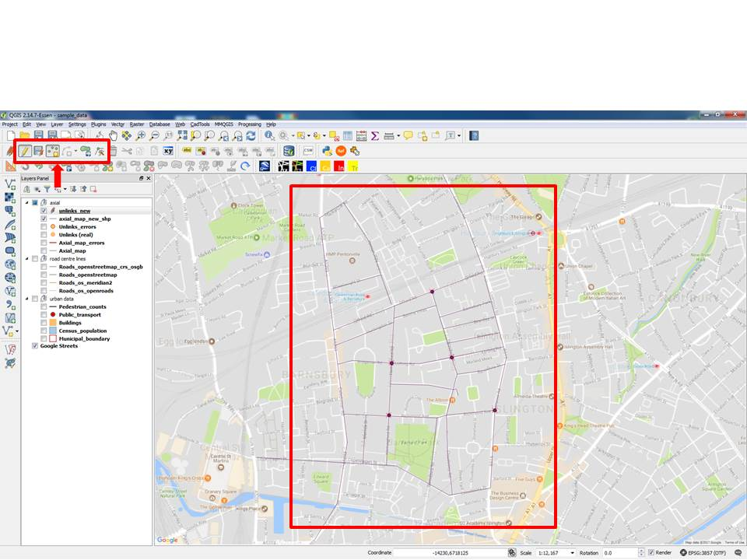

1. **Update axial “id” colum**
   1. Select the **‘axial_map_new’** layer
   2. Choose the **‘Field Calculator’** tool in the QGIS toolbar ***(Abacus icon).***
   3. Check **‘Update existing field’** and select the **‘id’ column**
   4. Find the expression “**$id**” or “**$rownum**”, or **@row_number** under **Variables** in the list.

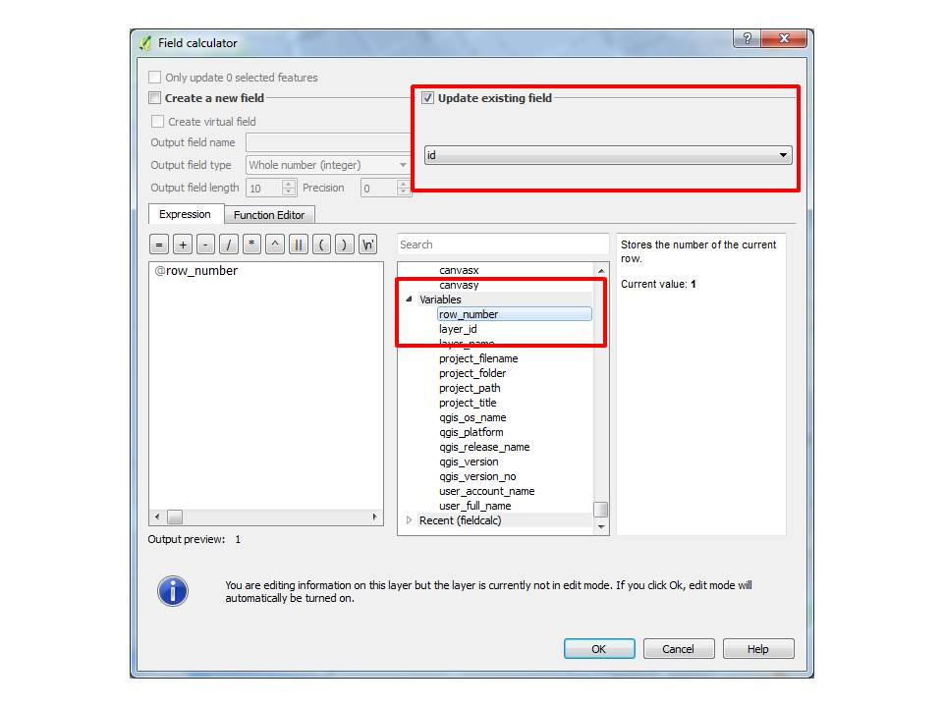

* 1. Double-click to add it to the **Expression window**
  2. You can also type any of the above expressions directly in the Expression window (without quotation marks)
  3. Click OK.
  4. This populates the **id column** with unique ids for every line created
  5. Un-toggle the **Editing mode** and save the file.

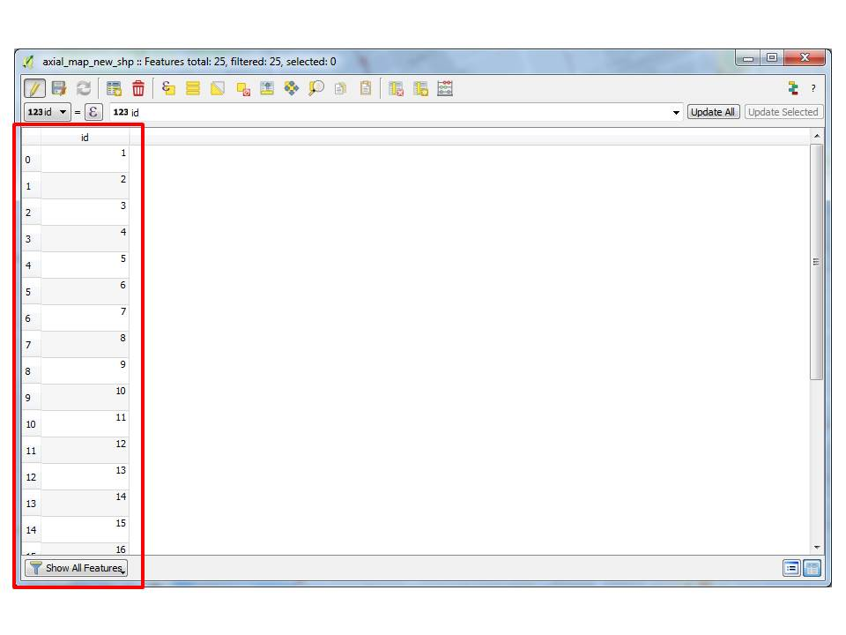

**Stage 3 – Model verification**

1. **Verify the axial map**
   1. Hide (un-check) the **“_new” layers** you just created as these are just for practicing digitising layers.
   2. Display (check) the **“axial_map_errors”** and **“unlinks_errors”** layers
   3. Click on the **“Graph analysis”** tool from Space Syntax Toolkit.
   4. Choose the **‘Map’** tab
   5. Select the **“axial_map_errors”** layer
   6. Click the **‘Verify’ button** in the **‘Verify layer’ tab**
   7. This results in a list of errors.
2. **Correct the axial errors**
   1. Toggle the “axial_map_errors” layer to make it editable.
   2. Select each error in the report list and this will zoom in to the error location.
   3. Edit the axial line **(delete, extend or move)** depending on the problem, using the digitizing toolbar buttons. In this example below, the error line has been extended deliberately across the perpendicular line, using the **Node Tool,** as you have already done in Step 4.
   4. Save Layer Edits of **“axial_map_errors”**

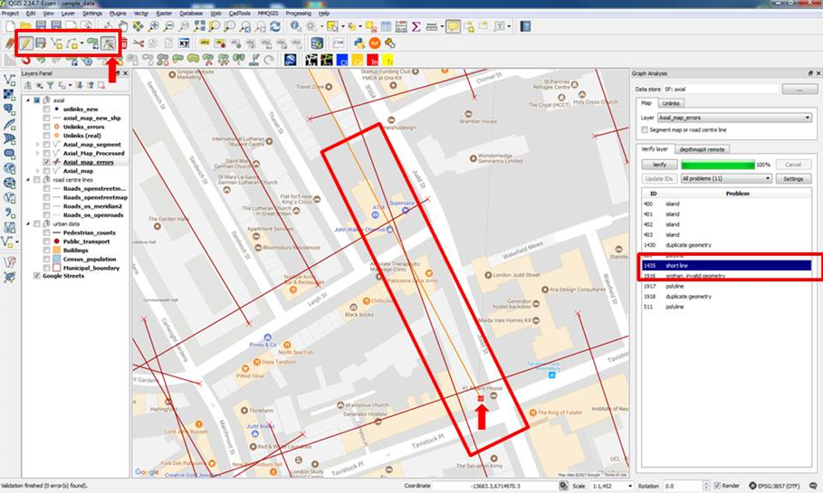

1. **Verify the unlinks**
   1. Choose the **‘Unlinks’ tab**
   2. Select the **“unlinks_errors” layer**
   3. Click **‘Verify’** in the **‘Verify layer’ tab**
   4. Notice the error message about IDs
   5. Click **‘Update IDs’**
   6. Click the **‘Verify’ button** again
   7. Now it analyses the unlinks in conjunction with the axial layer and reported errors.

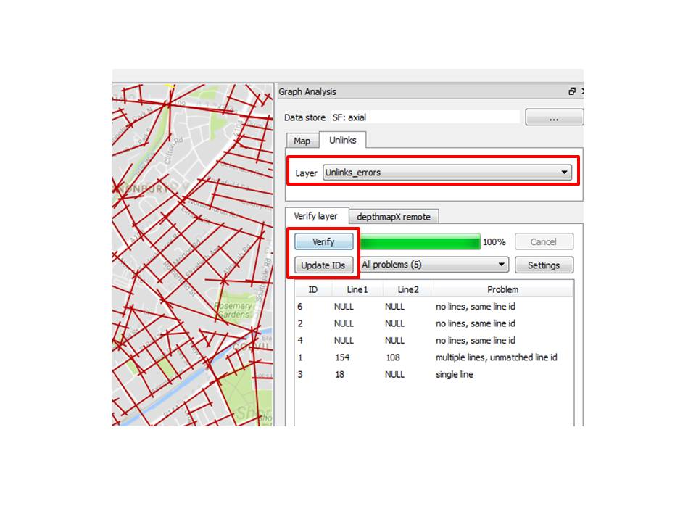

1. **Correct the unlinks errors**
   1. Toggle the “unlinks_errors” layer to be editable.
   2. Select each error in the report list to zoom to the problem
   3. Edit the unlink point accordingly (i.e delete, move), using the digitizing toolbar buttons. In this example below, the unlink point (id 6) has been moved accurately to the intersection. The error will disappear when you click ‘Update IDs’.
   4. Save Layer Edits of the “**unlinks_errors” layer**
   5. Update the IDs again if you make further edits with the ‘move’ tool.

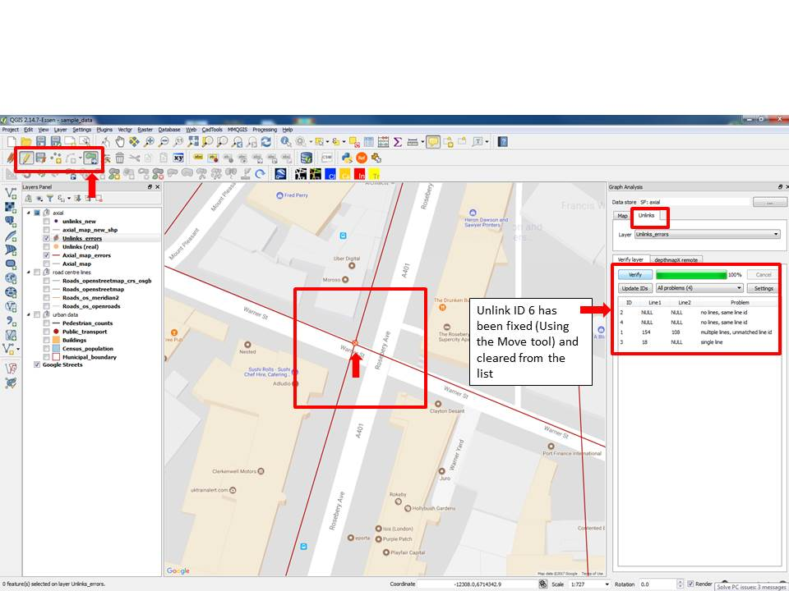

1. **Iterate the verification process**
   1. Choose the **Map tab**
   2. Verify the **axial map errors** again
   3. Correct the errors where necessary
   4. Return to the **unlinks tab** to verify unlinks. Do not forget to Update IDs.
   5. The verification process is only complete when there are **no errors** on **both** layers.

*\*\*You can move on to Stage 4 without correcting all the errors. This is just for you to practice.*

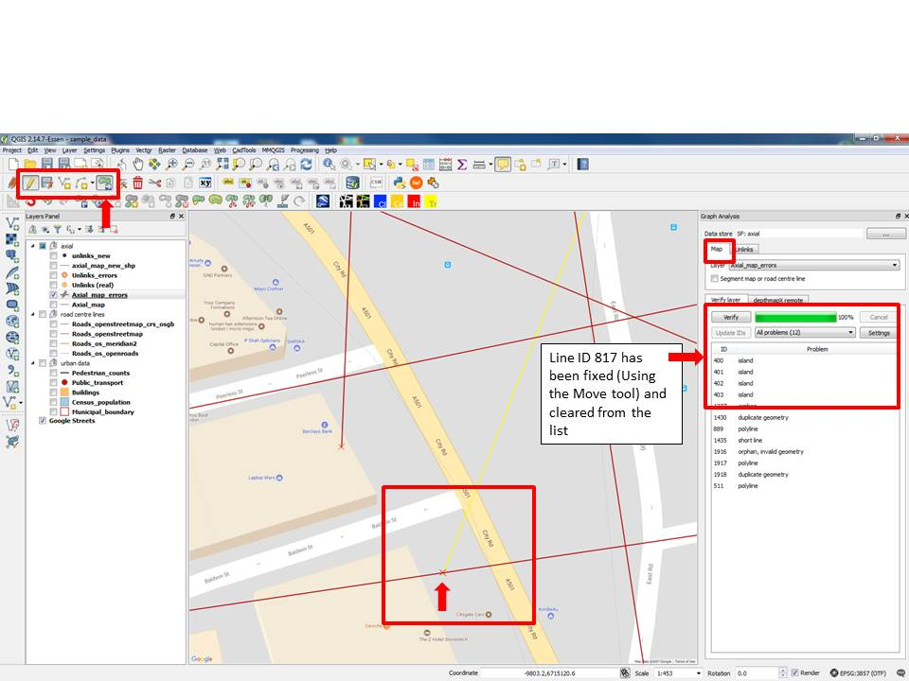

**Stage 4 – Model Analysis**

1. **Run Axial Analysis**
   1. Start/Open the depthmapX software. You **do not** have to do anything in this program, just make sure it is opened and running in the background.

*Back to your QGIS screen:*

* 1. Select the **“axial_map” layer** in the **“Map” tab**
  2. Select the **“unlinks(real)”** layer in the **“Unlinks” tab**
  3. Selectthe **“depthmapX remote” tab**
  4. Type in values in the **Radius field: “2, 4, n”**
  5. Type in new name in the output table as ***axial_map_analysis***
  6. Click Calculate.
  7. Open the Attribute Table of the newly created layer, to see the results.

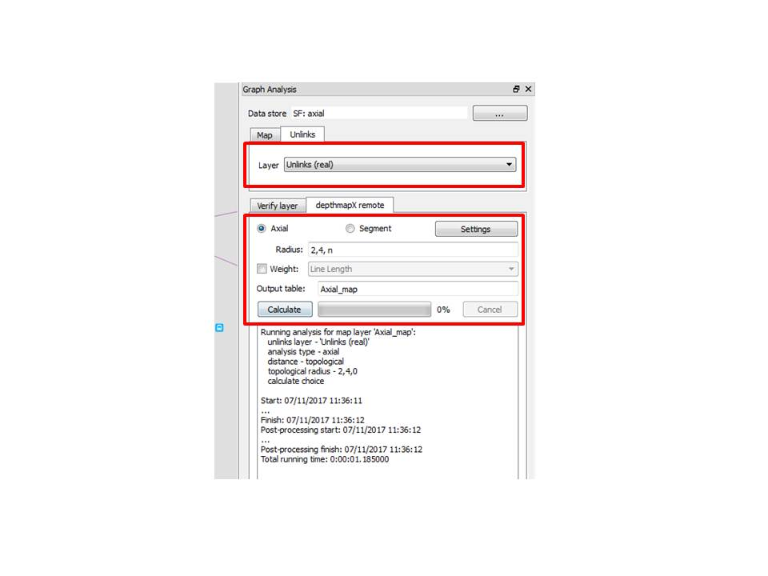 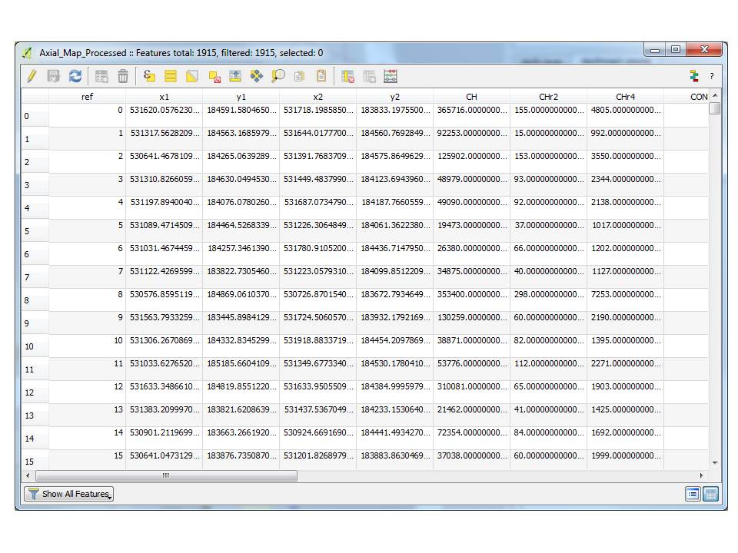

1. **Run Segment Analysis**
   1. Select **‘Segment’ option** in the **“depthmapX remote” tab**
   2. Type values in the **Radius field: “400, 800”** (do not use ‘n’ for now as it can be slow)
   3. Check the **“Weight”** box and select **“Segment Length”**
   4. Click the **Settings button**
   5. Check the “Calculate full set of measures” (optional)
   6. Click “Ok” to close the “Advance Settings” dialog
   7. Click “Calculate” and wait for a while.
   8. Open the **Attribute Table** of the newly created layer to see the results.
   9. Switch off all “axial” map layers, **leaving only the segment layer**
   10. Notice the difference in the model: trimmed line ends

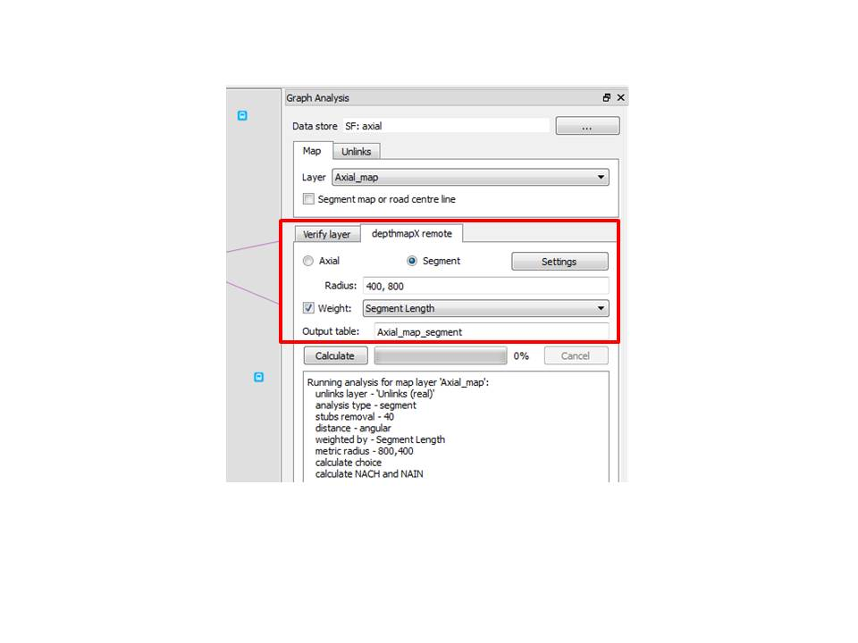

**Stage 5 – Results Visualisation**

1. **Visualise axial analysis results**
   1. Open the **“Attributes Explorer”** in the **Space Syntax Toolkit.**
   2. Select the **“axial_map_analysis”** layer
   3. Select the **“INT”** attribute *(INT is the abbreviation for Integration)*
   4. This shows the measures using the default space syntax style
   5. Click onother measures in the list to visualise the results.
   6. Click on the **‘Information Sign’ icon** (on the left of the ‘Select Features’ tool), then *click* on any line/polygon/point, a list of vital information of that selected feature will appear on the right of your screen.
   7. Set the **Mode** to **‘Layer selection’** if you wish to identify all features across all layers in the file, or keep it as **‘Current Layer’** if you wish to only identify features in the current layer.

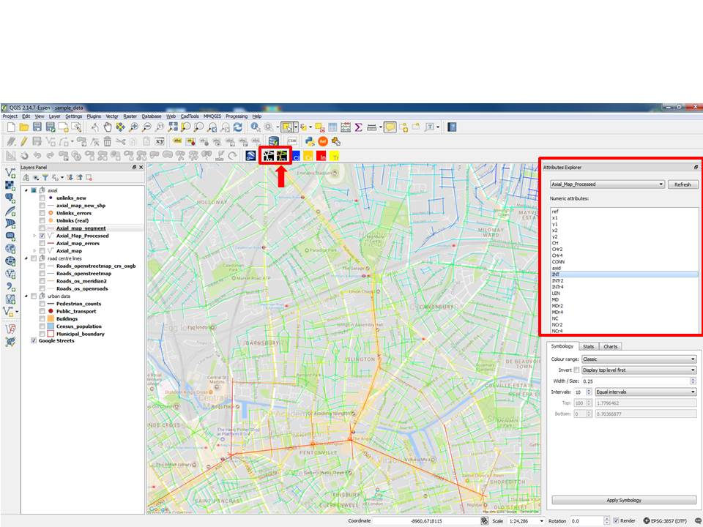

1. **Visualise segment analysis results for choice**
   1. Select the “**axial_map_segment”** to explore
   2. Select the **“CHr400m”** attribute
   3. Increase the **line width to 0.75**
   4. Set intervals to “Custom (Equal)”
   5. Change the ***Top*** value to **20**
   6. Click the **“Apply Symbology”** button
   7. This is the standard depthmapX display for the Choice measure

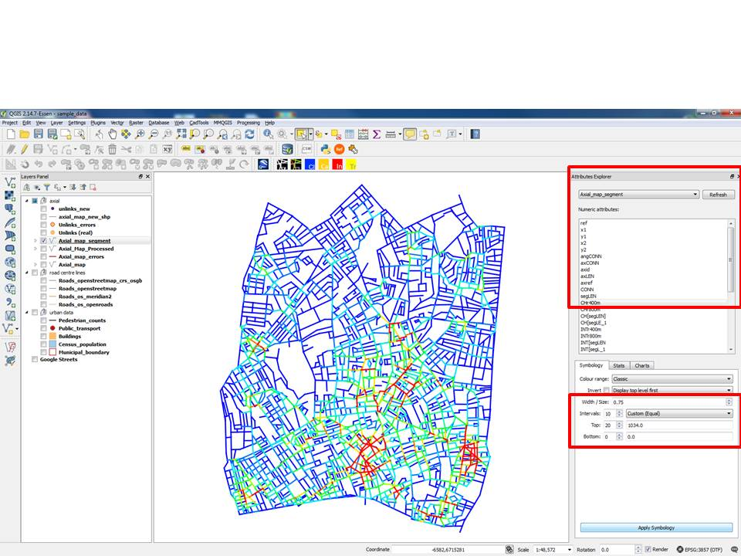

* 1. Set intervals to **“Natural breaks”**
  2. Click the **“Apply Symbology” button**

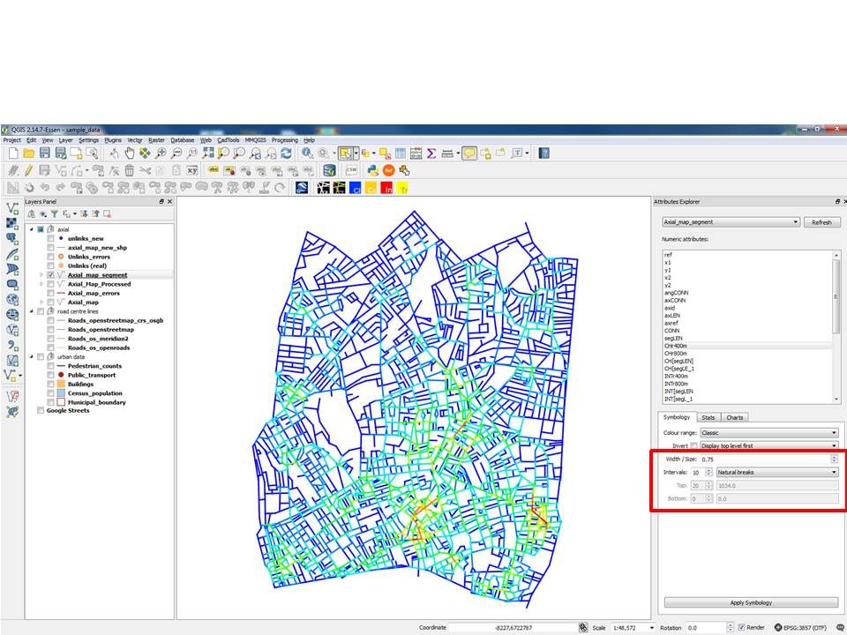

* 1. Set intervals to **“Quantiles”**
  2. Click the **“Apply Symbology”** button

